**Ideation Phase Define the**

**Problem Statements**

| Date | 31 june 2025 |
| --- | --- |
| Team ID | LTVIP2025TMID28960 |
| Project Name | Automated Car Catalog System For Enhanced Showroom Management |
| Maximum Marks | 2 Marks |

**Customer Problem Statement Template:**

Our showroom staff and potential customers need a quick, interactive, and informative way to explore available cars and manage car details because the current system is manual, outdated, and often leads to errors or confusion.

They feel overwhelmed when car information is missing, outdated, or hard to access, which slows down the sales process, affects customer satisfaction, and creates unnecessary workload for the staff.

We believe that by understanding their pain points and daily challenges, we can design an Automated Car Catalog System that streamlines car listings, improves accuracy, and provides a user-friendly experience—so both staff and customers can make decisions faster and more confidently.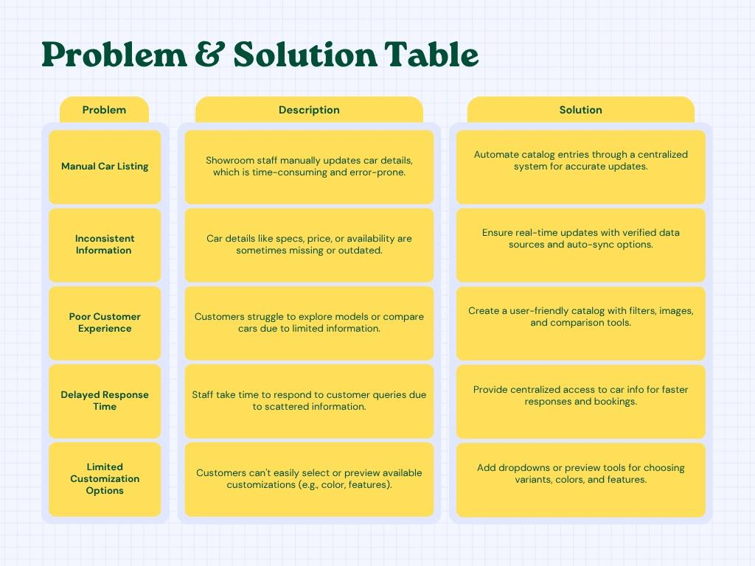

* **Example:**

| **Problem Statement (PS)** | **I am (Customer)** | **I’m trying to** | **But** | **Because** | **Which makes me feel** |
| --- | --- | --- | --- | --- | --- |
| **PS-1** | A showroom sales staff | Check car availability for a customer | I don’t know which car variants are in stock | the catalog is not updated in real time | Frustrated and helpless |
| **PS-2** | A customer | Compare two car models before buying | There is no proper comparison option | The catalog doesn’t support side-by-side comparisons | Confused and indecisive |
| **PS-3** | A manager | Generate car sales reports from catalog data. | The data is incomplete and scattered | Manual entries and lack of automation cause gaps | Stressed and delayed |

